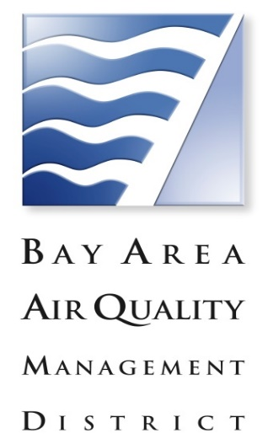

Lower-Emission School Bus Program (LESBP)
Incentive Participation Interest Form

This is not an application form. The data provided on this form will be used only for informational purposes. A complete application form will need to be submitted during an open solicitation period. This form does not reserve funding for a project.

SCHOOL DISTRICT/ JPA: ______________________________
Street Address: ____________________________________________________________
City: ___________________ County: ___________________ Zip:__________________

Contact Person:
Name: ___________________ Title: ________________________
Phone Number: ___________________ Fax Number: _________________
E-mail Address: ____________________________________________________

Project Type:
Replacement Retrofit CNG tank replacement Other: ________________

Number of Bus(es) by Model Year (likely to propose):
# of buses 1986 or older ________ # of buses between 1994 and 2003 _______
# of buses between 1987 and 1993 ______ # of buses 2004 or newer __________

Number of New Bus(es) by Fuel Type likely to propose (if applicable):
# of natural gas: ______________ # of diesel: _______________
# of hybrid/electric: ___________ # of propane: ______________

TOTAL FUNDING REQUESTED: $_______________________________________

Comments: _______________________________________________________________
_________________________________________________________________________
_________________________________________________________________________

If you have questions about the LESBP, please contact Lina Patel at (415) 749-5117 or lpatel@baaqmd.gov. General office contact information is grants@baaqmd.gov or
(415) 749-4994.

